

**Department of CSE**

**CSE209 Lab**

**Course Name: Electrical Circuits**

**Course Code: CSE209**

**Section No: 2**

**Experiment No: 05**

**Name of the Experiment:** Verification of Superposition Theorem.

**Date of submission: 09/09/21s**

Student’s Name: Md Abdul Ahad Rifat

Student’s ID: 2020-1-60-215

**Submitted to**

Rashedul Amin Tuhin

Senior Lecturer

Department of Computer Science and Engineering

East West University

**Objectives:**

1. To verify the superposition theorem theoretically, experimentally, and using PSpice simulation.

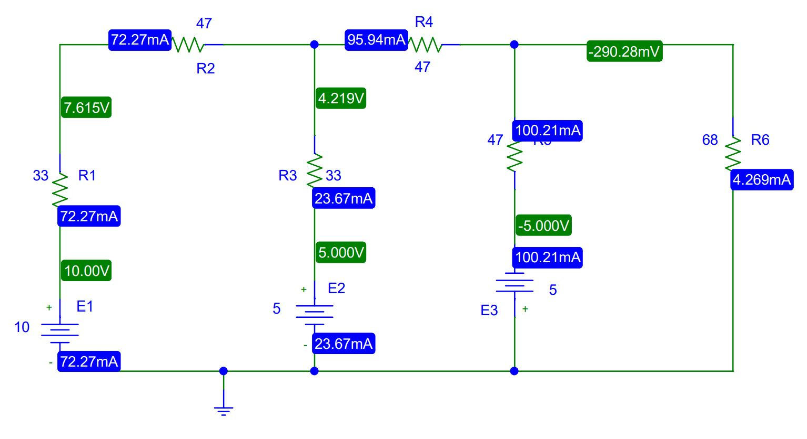**Circuit Diagram(s):**

**Figure 1.PSpice Schematic diagram for circuit 1**

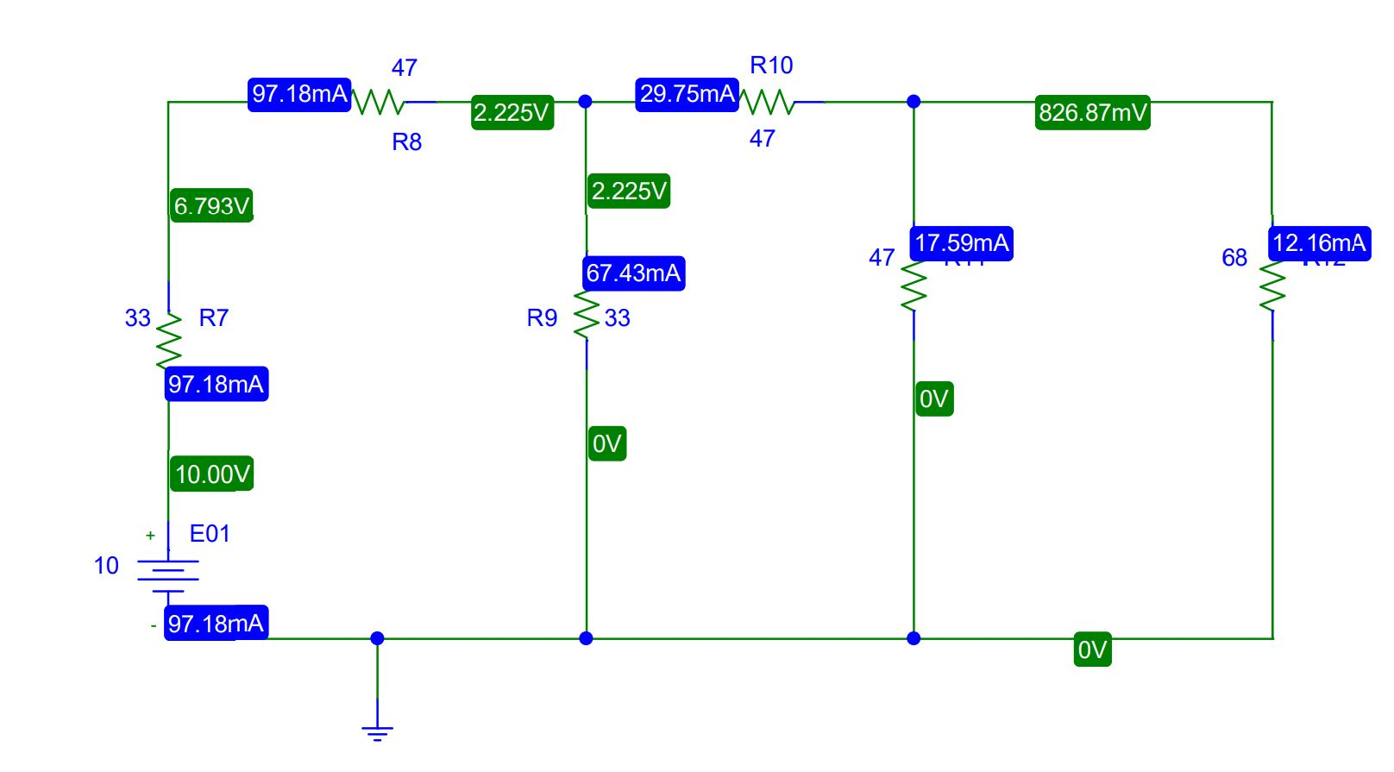

**Figure 2.PSpice Schematic diagram for circuit 2**

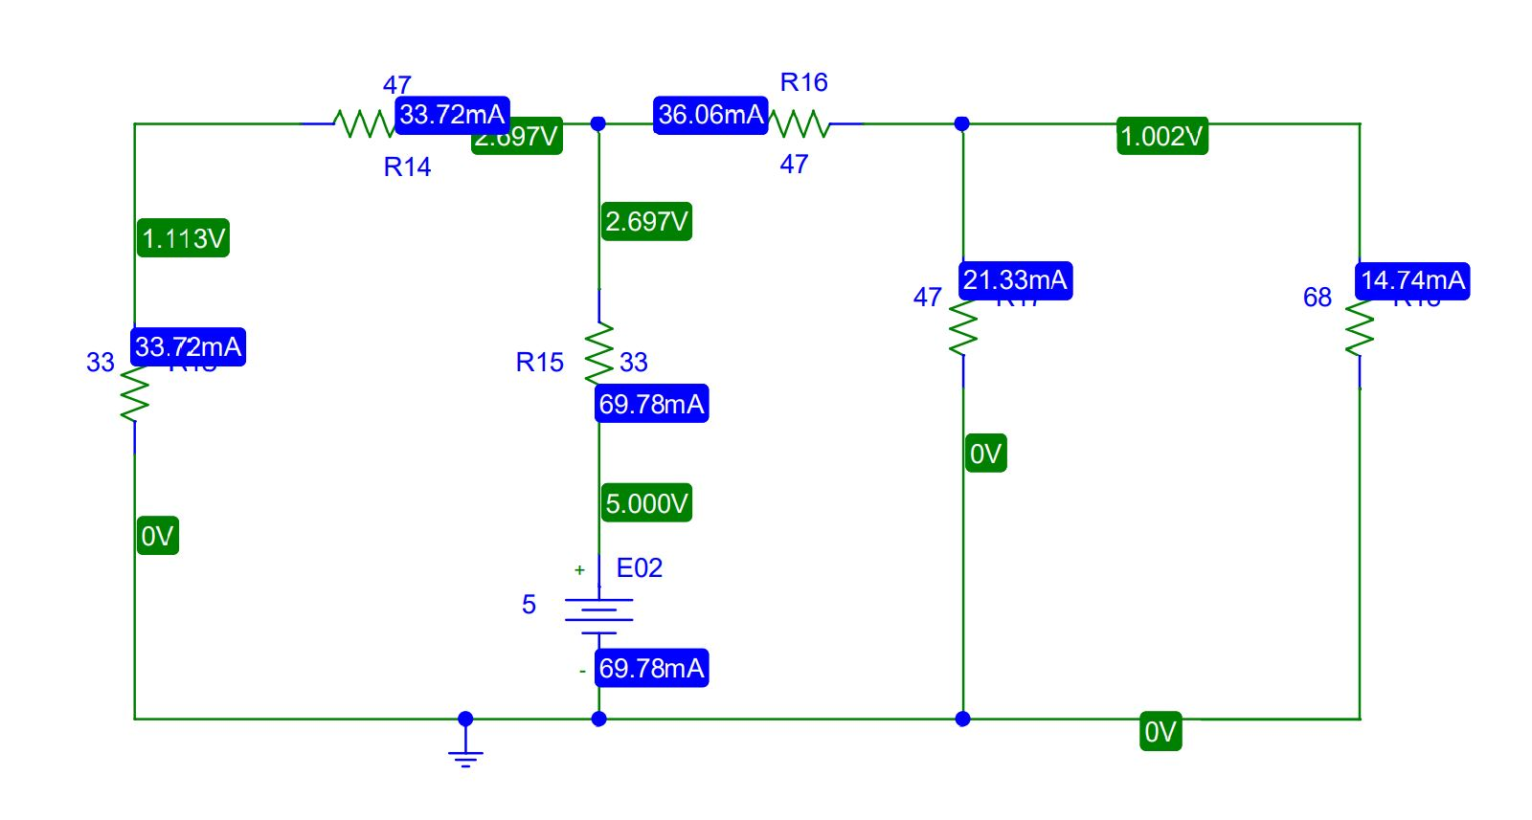

**Figure 3.PSpice Schematic diagram for circuit 3**

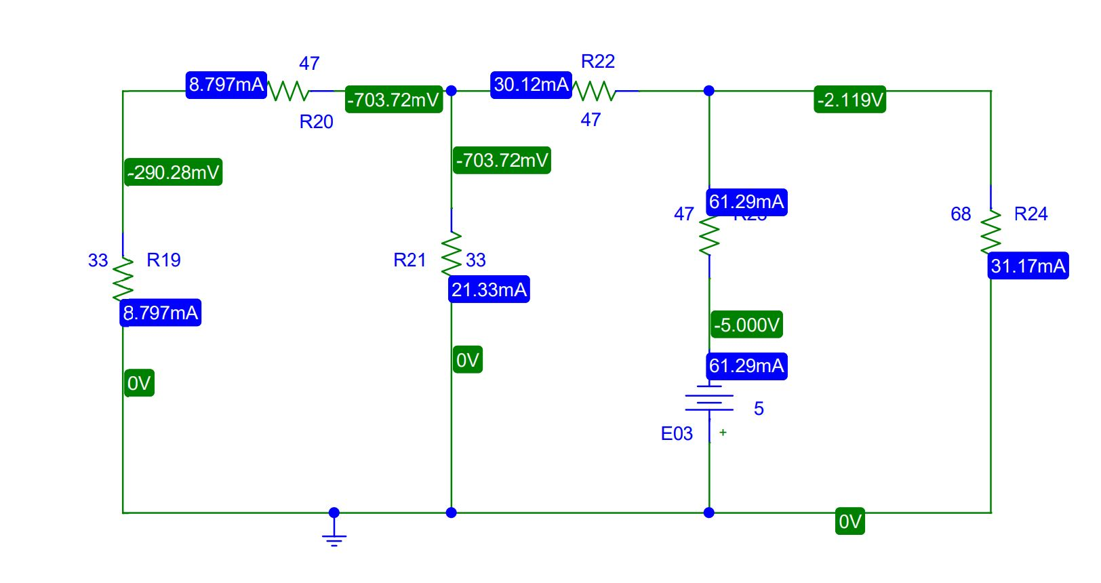

**Figure 4.PSpice Schematic diagram for circuit 4**

**Experimental Datasheet:**

|  |  |  |  |  |  |  |  |
| --- | --- | --- | --- | --- | --- | --- | --- |
| **Measured**  **Value of**  ***E1 (V)*** | **Measured**  **Value of**  ***E2 (V)*** | **Measured**  **Value of**  ***E3 (V)*** | **Measured**  **value of**  ***IL* with all**  **sources**  **active**  **(mA)** | **Measured**  **value of**  ***IL1* with**  **only *E1***  **active**  **(mA)** | **Measured**  **value of**  ***IL2* with**  **only *E2***  **active**  **(mA)** | **Measured**  **value of**  ***IL3* with**  **only *E3***  **active**  **(mA)** | **Measured**  **values of**  **resistors**  **Ω** |
| **10** | **5** | **5** | **-4.269** | **12.16** | **14.74** | **-31.17** | **R1 = 33**  **R2 = 47**  **R3 = 33**  **R4 = 47**  **R5 = 47**  **RL = 68** |

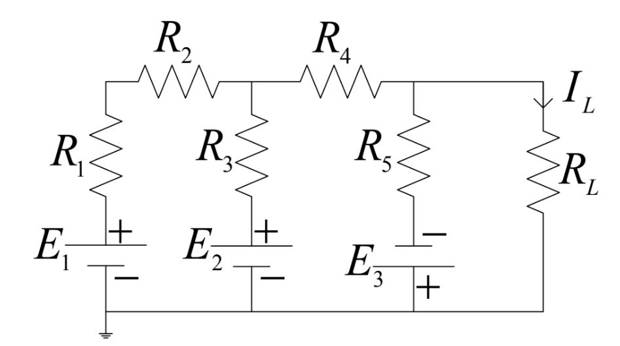**Post-Lab Report Questions and Answers:**

**Figure 5.Circuit with all sources active.**

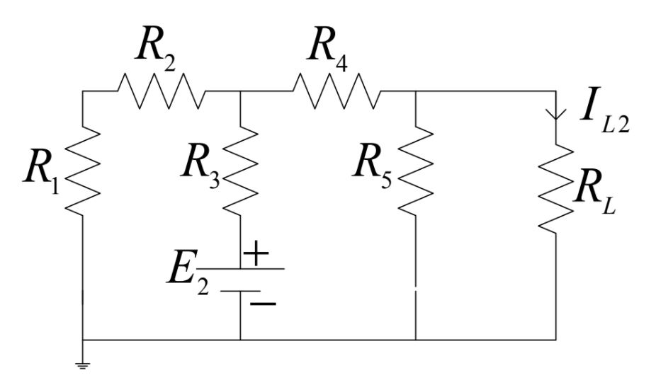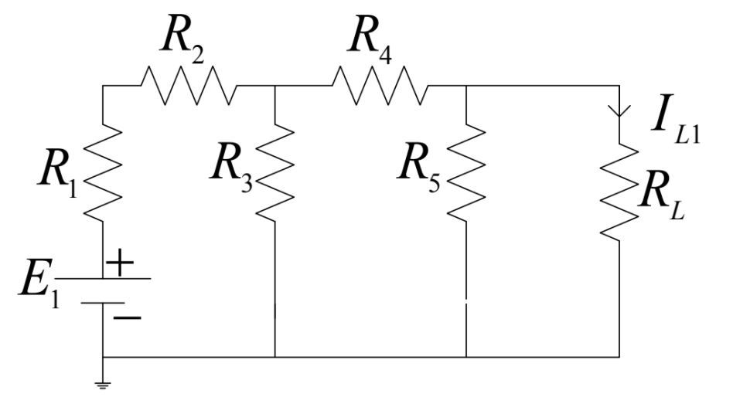

**Figure 6.Circuit with E1 source active**

**Figure 7.Circuit with E2 source active**

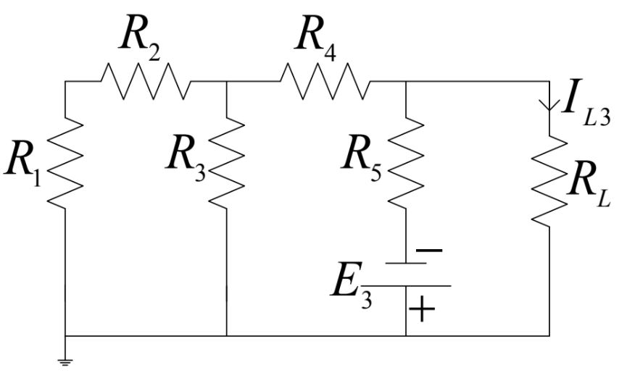

**Figure 8.Circuit with E3 source active**

1. Calculate the values of IL, IL1, IL2, and IL3 of the circuits of Figures 5 through 7 using the measured values of E1, E2, E3, R1, R2, R3, R4, R5, and RL. From the calculated values show that the superposition theorem holds. Compare these calculated values of currents with the experimental values and comment on any discrepancy observed.

**Answer:**

In figure 5,

Applying KVL at meh 1;

$$10-{33i}_{1}-{47i}_{1}-{33i}_{1}+{33i}_{2}-5=0$$

${113i}_{1}-{33i}_{2}=5$………… (1)

Applying KVL at meh 2;

$$10-{33i}_{2}+{33i}_{1}-{47i}_{2}-{47i}_{2}+{47i}_{3}=0$$

${-33i}_{1}+{127i}_{2}-{47i}_{3}=10$………… (2)

Applying KVL at meh 3;

$-5-{47i}_{3}+{47i}_{2}-{68i}_{3}=0$ $\left[ I_{L}=i_{3}\right]$

$-{47i}_{2}+{115i}_{3}=-5$………… (3)

Solving equation (1), (2) and (3) and we will get,

$$I_{L}=i_{3}=-4.268mA$$

In figure 6,

Applying KVL at meh 1;

$$10-{33i}_{1}-{47i}_{1}-{33i}_{1}+{33i}_{2}=0$$

${113i}_{1}-{33i}_{2}=10$………… (1)

Applying KVL at meh 2;

$$-{33i}_{2}+{33i}_{1}-{47i}_{2}-{47i}_{2}+{47i}_{3}=0$$

${-33i}_{1}+{127i}_{2}-{47i}_{3}=0$………… (2)

Applying KVL at meh 3;

$-{47i}_{3}+{47i}_{2}-{68i}_{3}=0$ $\left[ I_{L1}=i_{3}\right]$

$-{47i}_{2}+{115i}_{3}=0$………… (3)

Solving equation (1), (2) and (3) and we will get,

$$I_{L1}=i_{3}=12.16mA$$

In figure 7,

Applying KVL at meh 1;

$$-{33i}_{1}-{47i}_{1}-{33i}_{1}+{33i}_{2}-5=0$$

${-113i}_{1}+{33i}_{2}=5$………… (1)

Applying KVL at meh 2;

$$5-{33i}_{2}+{33i}_{1}-{47i}_{2}-{47i}_{2}+{47i}_{3}=0$$

${33i}_{1}-{127i}_{2}+{47i}_{3}=-5$………… (2)

Applying KVL at meh 3;

$-{47i}_{3}+{47i}_{2}-{68i}_{3}=0$ $\left[ I_{L2}=i_{3}\right]$

$-{47i}_{2}+{115i}_{3}=0$………… (3)

Solving equation (1), (2) and (3) and we will get,

$$I_{L2}=i_{3}=14.74mA$$

In figure 8,

Applying KVL at meh 1;

$$-{33i}_{1}-{47i}_{1}-{33i}_{1}+{33i}_{2}=0$$

${-113i}_{1}+{33i}_{2}=0$………… (1)

Applying KVL at meh 2;

$$-{33i}_{2}+{33i}_{1}-{47i}_{2}-{47i}_{2}+{47i}_{3}+5=0$$

$-{33i}_{1}+{127i}_{2}-{47i}_{3}=5$………… (2)

Applying KVL at meh 3;

$-{47i}_{2}+{115i}_{3}=-5$………… (3) $\left[ I_{L3}=i_{3}\right]$

Solving equation (1), (2) and (3) and we will get,

$$I_{L3}=i_{3}=-31.17mA$$

Now Superposition Theorem we all know,

IL = IL1 + IL2 + IL3

Or, -4.27 = 12.16+14.74+ (-31.17)

Or, -4.27 = -4.27

In this experiment, IL and IL1 + IL2 + IL3 current values are the same. There is no discrepancy between these values. So we say that our all the calculated values is correct and its follow the Superposition theorem.

1. From the PSpice solution show that the superposition theorem holds. Compare the PSpice solutions with the theoretical solutions and comment on any discrepancy found.

**Answer:** There has been no change in theoretical calculation value in Figures 5 to 8 and Pspice simulation value in Figures 1 to 4. But in the real lab, if we calculate the value then we get some discrepancy but in Pspice we get exact same value. Theoretical calculation and Pspice simulation both of these values are the same and there has been no discrepancy between them. **The superposition theorem states that a circuit with multiple voltage and current sources is equal to the sum of simplified circuits using just one of the sources**. So this experiment totally follows these rules.

**Discussion:**

In the actual lab when we create a short circuit that time we must be removed the voltage source. Some people do not remove voltage sources they are connected wire in parallel but this is wrong. When they do it into this current pass the circuit and circuit will get burn. So must follow our instructor's rule Otherwise we will get into big trouble in our lab. Because if we connected wire voltage source in parallel that means we connected source positive and negative side in together in that time circuit will obviously burn, so we must follow the proper guidelines

In the lab, we use trainer board to connect the sources. Because our lab doesn't have more voltage or current sources. So one source connect in the main voltage source and the other source connect into the trainer board

**Conclusion:**

During lab experiment 7 we calculate and analyze the currents using the Superposition theorem. And we calculate our value theoretically and PSpice simulation software and there has been no discrepancy between them. Also, we understand when we will need a short circuit in that time we will remove voltage sources otherwise our circuit will get burn.

**Reference:**

<https://onlinelibrary.wiley.com/doi/abs/10.1002/9781119580164.ch23#:~:text=The%20superposition%20theorem%20states%20that,just%20one%20of%20the%20sources>.